Ex 6
Aim
To design and develop a prototype of an E-commerce Shopping Application using the RAD (Rapid Application Development) model, focusing on quick UI design, user interaction, and iterative development using Axure.
Procedure
- 1. Requirement Planning
Identified key features such as Home, Categories, Product Listings, Product Details, Cart, Checkout, and Order Confirmation. Defined user actions including browsing, searching, adding to cart, and checkout.
- 2. User Design
Designed wireframes using Axure for all major screens. Used prototype linking, reusable components, and annotations.
- 3. Construction
Developed interactive prototypes with navigation flow from Home to Order Confirmation. Added dynamic interactions and tested the prototype.
- 4. Cutover
Finalized the prototype, shared with stakeholders, and prepared for development handoff.
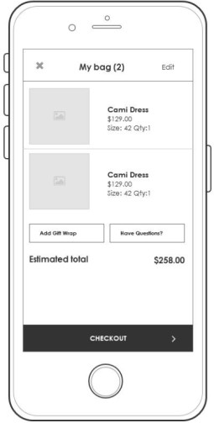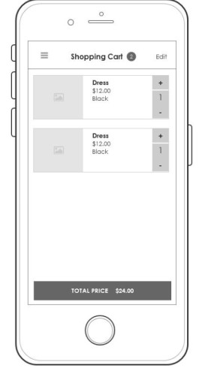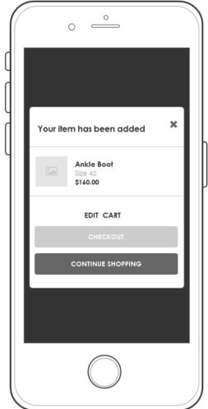

Results:
The RAD-based prototype was successfully developed with smooth navigation, interactive UI elements, and a user-friendly interface. The project demonstrated rapid development using Axure and effective usability for an e-commerce application.

